*Florida International University*

*School of Computing and Information Sciences*

CIS 4911 - Senior Capstone Project

Software Engineering Focus

Feature Document

User Story # 708

**Team Member:**

Garrett Lemieux

**Product Owner(s)**:

Francisco Ortega

**Mentor(s)**:

Francisco Ortega

**Instructor**: Masoud Sadjadi

**User Story – Implement Drawing with hands using real sense device**

* As a user I would like to be able to draw using Real Sense device in order to allow more interaction with paint program when using Real Sense Device.
* **Acceptance Criteria**:

1. User must be able to interact with paint program in a way other than facial gestures.
2. Hand interaction with device must be implemented.
3. User must be able to draw using hands with real sense device.

**Use Case:**

User wants to draw using the real sense device.

* Details:
* Actor:
  + User
* Pre-conditions:
  + Real Sense must be connected to TouchPoints application.
  + TouchPoints app is running.
* Description:
  + Use case begins user decides to draw using real sense.
  + User enters hover zone with either left or right hand.
  + User can then enter drawing zone by going closer to the real sense.
  + Once in drawing zone user draws by moving hand around canvas.
  + Use case ends when users hand exits drawing and hover zone.
* Post-conditions:
  + User should be able to view shapes drawn on canvas.
* Decision Support:
  + Frequency: Medium, User does not have to use real sense device to draw.
  + Criticality: High, Need a way to draw if only real sense is connected.
  + Risk: Medium
* Usability:
  + User needs to know how the hover zone and drawing zone work.
* Reliability
  + High
* Performance
  + Performance Low
  + Failure Low
* Supportability
  + Real Sense Device
* Modification History:
  + Owner: Garrett Lemieux
  + Initiation Date 4/11/2016
  + Date last Modified: 4/17/2016

**Use Case Diagram**

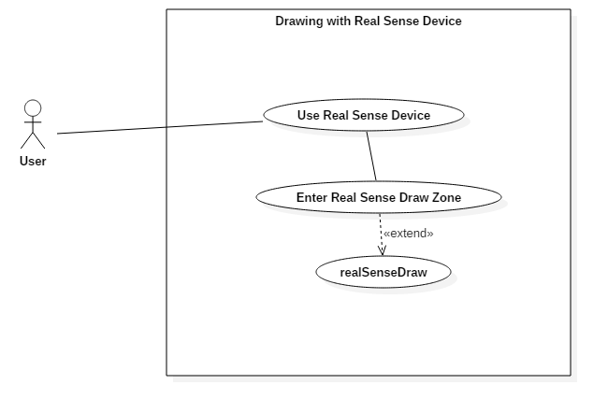

**Sequence Diagram**

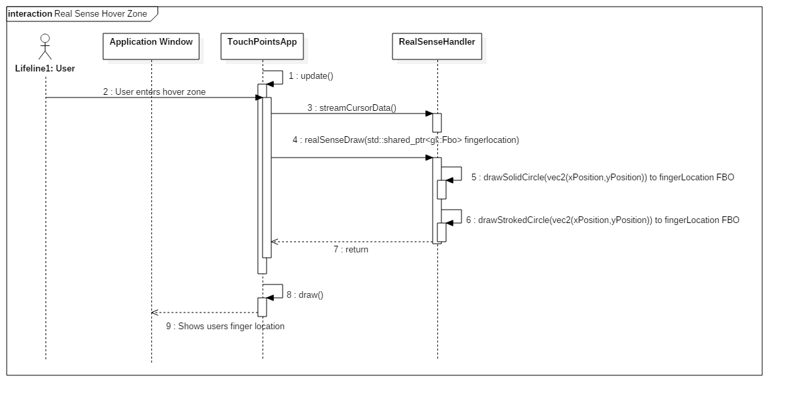



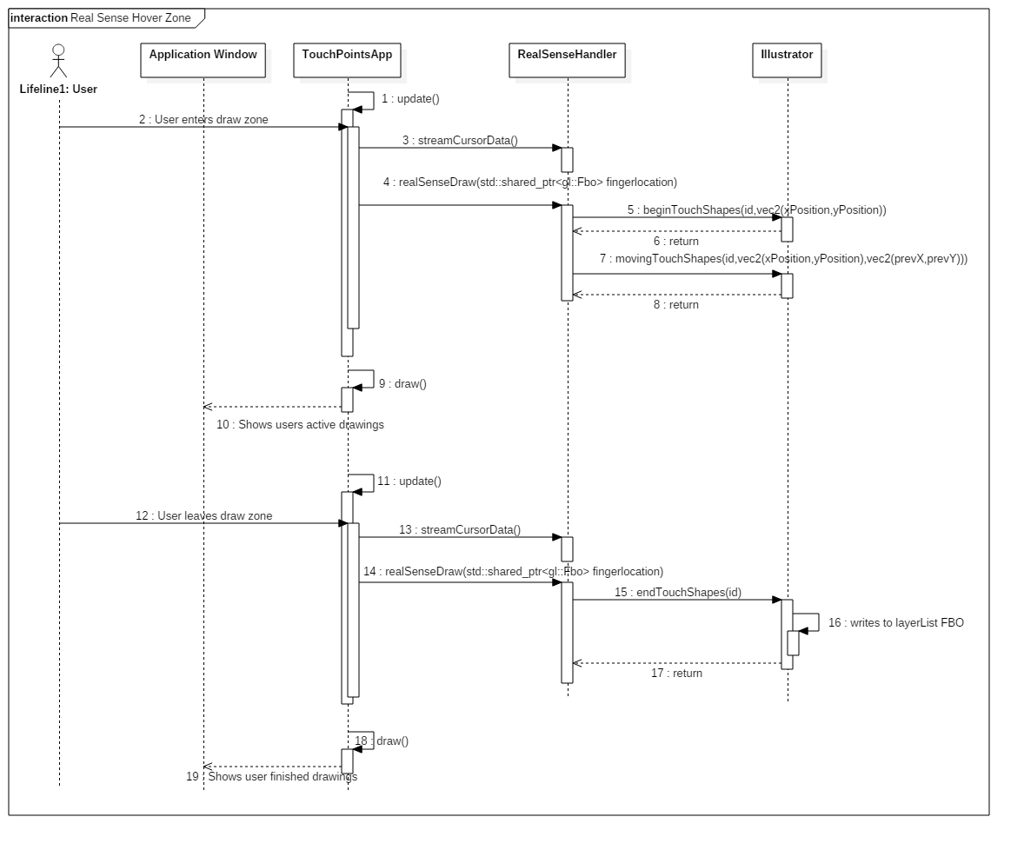

**Class Diagram**

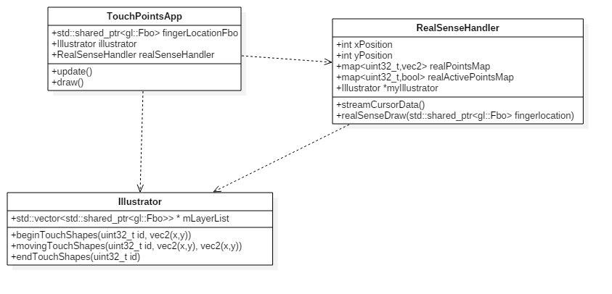

**Unit Test**

* Sunny Day Test:
  + Test Case  - Real Sense Hover Zone
    - Test Purpose: Test if a user can enter the hover zone and provided feedback of finger location.
    - Test Procedure: User starts application. Then slowly moves right hand with index finger extended toward screen. Then observes results. This procedure is repeated with left hand.
    - Expected Results: As user’s right hand moves toward canvas a green circle should appear once hover zone is entered by user. Same should occur when left hand is used.
  + Test Case  - Real Sense Hover Zone Canvas Coverage
    - Test Purpose: Test the coverage of hover zone and whether all parts of canvas can be hovered over.
    - Test Procedure: User starts application. Then slowly moves right hand with index finger extended toward screen. Once enters hover zone he or she moves hand in all directions and covers entire canvas.
    - Expected Results: As user’s right hand moves toward canvas a green circle should appear once hover zone is entered. When user moves hand around canvas the green circle should follow the hand and every part of the canvas should be accessible.
  + Test Case  - Real Sense Draw Zone
    - Test Purpose: Test if a user can enter the draw zone and provided feedback.
    - Test Procedure: User starts application. Then slowly moves right hand with index finger extended toward screen. He or she enters hover zone and then continues to move toward screen until draw zone has been entered. Then observes results. This procedure is repeated with left hand.
    - Expected Results: As user’s right hand moves toward canvas a green circle should appear once hover zone is entered by user. Once user enters draw zone green circle should disappear and shape currently selected should appear on canvas at specified location. Same should occur when left hand is used.
  + Test Case  - Real Sense Draw Zone Canvas Coverage
    - Test Purpose: Test the coverage of draw zone and whether all parts of canvas can be drawn to.
    - Test Procedure: User starts application. Then slowly moves right hand with index finger extended toward screen. Once enters hover zone he or she moves further towards screen until draw zone entered. User should then attempt to draw on all parts of canvas.
    - Expected Results: As user’s right hand moves toward canvas a green circle should appear once hover zone is entered. User should then see circle disappear when draw zone entered. As user attempts to draw in all sections of canvas current shape should be drawn.
* Rainy Day Test:
  + Test Case  - User exits Real Sense boundaries while in Hover Zone
    - Test Purpose: Test if user exits boundaries while in hover zone expected result will occur.
    - Test Procedure: User enters hover zone and begins to move around canvas. He or she accidently leaves real sense boundary and observes result.
    - Expected Results: When user leaves real sense boundary the green circle should disappear. If green circle remains or program experiences any non-expected actions then test fails.
  + Test Case  - User exits Real Sense boundaries while in Draw Zone
    - Test Purpose: Test if user exits real sense boundaries while in draw zone expected result will occur.
    - Test Procedure: User enters draw zone and begins to draw on canvas.

He or she accidently leaves real sense boundary and observes result.

* + - Expected Results: When user leaves real sense boundary drawing should stop immediately. If program experiences any non-expected actions then test fails.

**Integration Testing**

* Real Sense drawing was testing using each shape and color.
* All devices that have the ability to draw where tested by altering devices that are used to draw.
* After integrating the real sense drawing into application all previous functionality was retained.

**User Guide**

* Devices Used: Real Sense Device

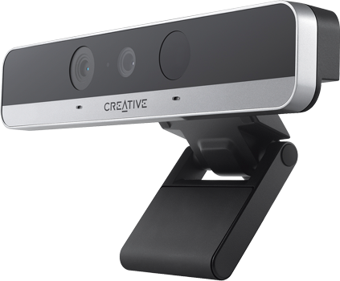

* User must use only one hand at a time to draw with the Real Sense.
* He or she should have palm closed with index finger extended.
* In order to enter hover zone user slowly moves hand towards desired location on canvas and will be provided feedback in the form of a green circle when hand has entered hover zone.

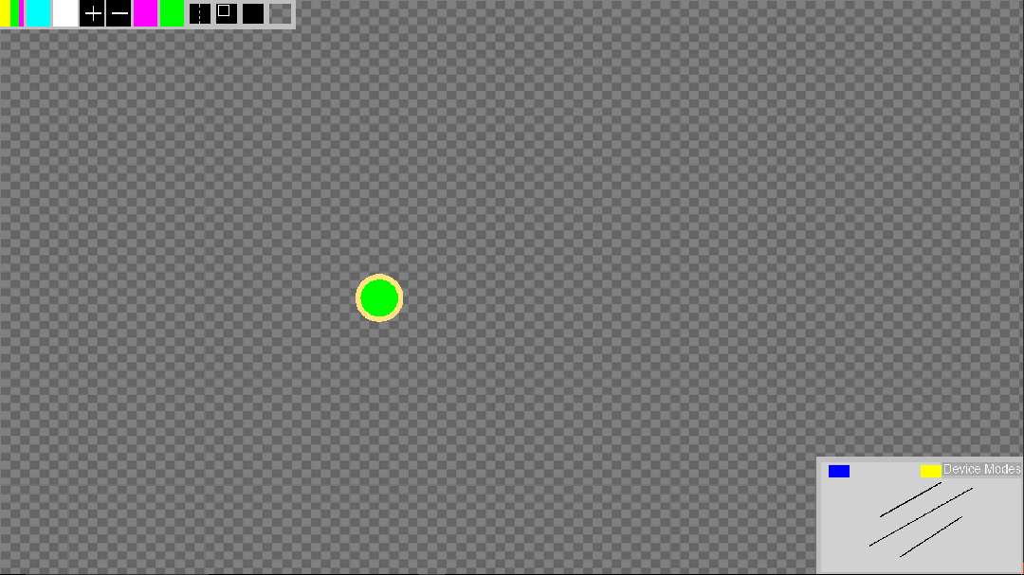

* In order to enter draw zone user must first enter hover zone and then continue moving toward desired location on canvas. Once draw zone has been entered user will see the current shape and color being drawn to canvas.

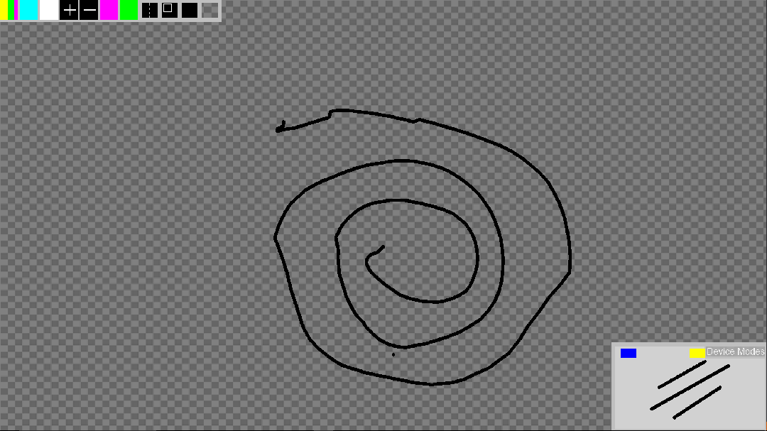

* Once draw zone has been entered user can draw on any part of the canvas by moving his or her hand like a cursor to the desired location on canvas.
* User can expected drawing to stop if he or she tries to draw outside the canvas.

**Glossary**

* **Real Sense Hover Zone** – Area before draw zone indicates to user current position of user’s finger. The hover zone is the area that is between .35 mm and .5 mm from real sense in the z direction.
* **Real Sense Draw Zone** – Area where drawing takes places. The drawing zone is the area that is between 0 mm and less than .35 mm from real sense in the z direction. When finger is in drawing zone the current shape and color settings are used to draw the shape on canvas.